nepal college of information Technology

Level: Bachelor | Semester – Fall | Year : 2015
Programme: BE Civil/IT |  | Full Marks : 100
Course: Basic Electrical Engineering |  | Time : 3hrs.

Candidates are required to give their answers in their own words as far as practicable.
The figures in the margin indicate full marks.

Attempt all the questions.

1. | - Find out the magnitude and direction of current flowing through the 1Ω resistance.  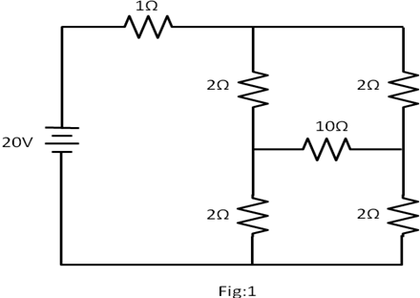  - Calculate the currents i₁, i₂, and i₃ of the following network.  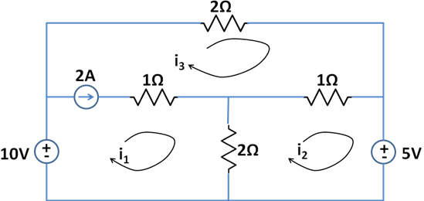 | 7  8
2. | - State and explain Superposition Theorem for DC circuit analysis.  - Calculate the current through 3Ω resistor using Thevenin’s theorem in fig 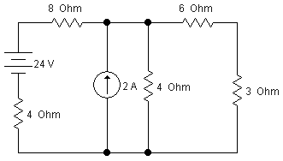 | 7  8
3. | - Find the average value, rms value, form factor & peak factor of sinusoidal waveform?  - An impedances of (3-j8) and (2+j15) are connected in parallel. The circuit is fed from a 230V, 50Hz supply. Find the current through each branch, total circuit current, impedance, p.f., active power, reactive power and apparent power? | 7  8
4. | - A series R-L-C circuit has 10Ω resistance, 0.01H inductance, and 100µF capacitor. A 100V supply with variable frequency is applied to this circuit and tuned until resonance occurs. Find the resonant frequency, bandwidth, and quality factor, current drawn by the circuit, and voltage across inductor at resonance condition.  - A Δ-connected balanced 3¢ load is supplied from a 3¢, 400V supply. The line current is 20A and the power taken by the load is 10,000 W. Find  i) impedance in each branch  ii) the line current, power factor and power consumed if the same load is connected in star. | 7  8
5. | - Explain the measurement of 3-phase power by Two-wattmeter method.  - 10KVA , 200/400 V, 50Hz, 1¢ transformer gave the following test results:  O.C test (HV side open): 200V, 1.3A, 120W  S.C test (LV side S.C.): 22V, 30A, 200W  Find the parameters of equivalent circuit as referred to HV side. | 7  8
6. | - Explain the types of speed control methods of DC motar.  - A 240 V shunt motor runs at 1450 rpm of full load with an armature current of 11A. The total resistance of the armature and brushes is 0.6Ω. If the speed is to be reduced to 1000 rpm with the same armature current, calculate the value of resistance to be connected in series with the armature. | 7  8
7. | Write Short notes on: (Any Two)  - Permanent Magnet Moving Coil instrument  - Advantages of 3 phase system  - Norton’s Theorem | 5×2

